BANK LOAN QUERY DOCUMENT

- Summary
- Total Loan Application
SELECT COUNT(id) as Total_Loan_Applicants FROM bank_loan_data;
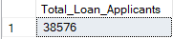

- Total Loan Amount
SELECT SUM(loan_amount) as Total_Loan_Amount FROM bank_loan_data;
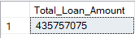

- Total Amount Received
SELECT SUM(total_payment) as Total_Amount_Received FROM bank_loan_data;


- Average Interest Rate
SELECT ROUND(AVG(int_rate), 4) * 100 as Avg_Interest_Rate FROM bank_loan_data;
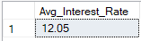

- Average Debt to Income Rate
SELECT ROUND(AVG(dti), 4) * 100 as Avg_DTI FROM bank_loan_data;
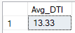

- Good Loan Application
SELECT COUNT(id) as Good_Loan_Application FROM bank_loan_data
WHERE loan_status = 'Fully Paid' OR loan_status = 'Current';
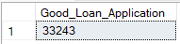

- Good Loan Percentage
SELECT
COUNT(CASE WHEN loan_status = 'Fully Paid' OR loan_status = 'Current' THEN id END) * 100
/
COUNT(id) as Good_Loan_Percentage
FROM bank_loan_data;
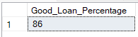

- Good Loan Funded Amount
SELECT SUM(loan_Amount) as Good_Loan_Funded_Amount FROM bank_loan_data
WHERE loan_status = 'Fully Paid' OR loan_status = 'Current';
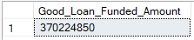

- Good Loan Amount Received
SELECT SUM(total_payment) as Good_Loan_Amount_Received FROM bank_loan_data
WHERE loan_status = 'Fully Paid' OR loan_status = 'Current';
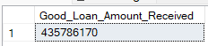

- Bad Loan Application
SELECT COUNT(id) as Bad_Loan_Application FROM bank_loan_data
WHERE loan_status = 'Charged Off';
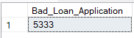

- Bad Loan Percentage
SELECT
COUNT(CASE WHEN loan_status = 'Charged Off' THEN id END) * 100
/
COUNT(id) as Bad_Loan_Percentage
FROM bank_loan_data;
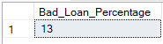

- Bad Loan Funded Amount
SELECT SUM(loan_amount) as Bad_Loan_Funded_Amount FROM bank_loan_data
WHERE loan_status = 'Charged Off';
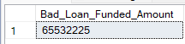

- Bad Loan Amount Received
SELECT SUM(total_payment) as Bad_Loan_Amount_Received FROM bank_loan_data
WHERE loan_status = 'Charged Off';
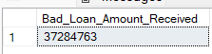

- Loan Status
SELECT
COUNT(id) as Total_Application,
SUM(total_payment) as Total_Amount_Received,
SUM(loan_amount) as Total_Funded_Amount,
ROUND(AVG(int_rate * 100), 4) as Interest_Rate,
ROUND(AVG(dti * 100), 4) as DTI
FROM bank_loan_data
GROUP BY loan_status;
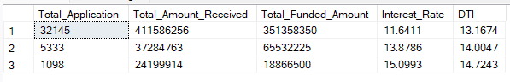

- Overview

- Loan Amount Status by Month
SELECT
MONTH(issue_date) as Month_Num,
DATENAME(MONTH, issue_date) as Month,
COUNT(id) as Total_Application,
SUM(loan_amount) as Total_Funded_Amount,
SUM(total_payment) as Total_Amount_Received
FROM bank_loan_data
GROUP BY MONTH(issue_date), DATENAME(MONTH, issue_date)
ORDER BY MONTH(issue_date);
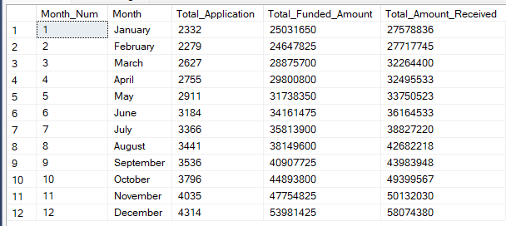

- Loan Amount Status by Term
SELECT
term,
COUNT(id) as Total_Application,
SUM(loan_amount) as Total_Funded_Amount,
SUM(total_payment) as Total_Amount_Received
FROM bank_loan_data
GROUP BY term
ORDER BY term;
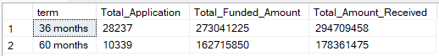

- Loan Amount Status by State
SELECT
address_state,
COUNT(id) as Total_Application,
SUM(loan_amount) as Total_Funded_Amount,
SUM(total_payment) as Total_Amount_Received
FROM bank_loan_data
GROUP BY address_state
ORDER BY COUNT(id) DESC;
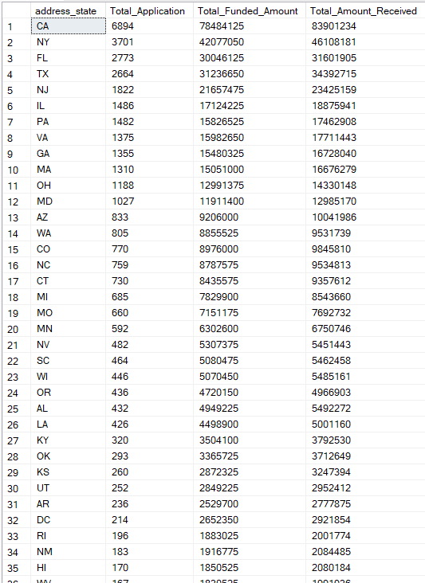
- Loan Amount Status by Employee Experience
SELECT
emp_length,
COUNT(id) as Total_Application,
SUM(loan_amount) as Total_Funded_Amount,
SUM(total_payment) as Total_Amount_Received
FROM bank_loan_data
GROUP BY emp_length
ORDER BY COUNT(id) DESC;
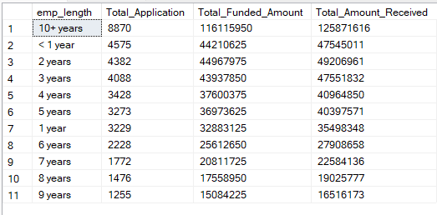

- Loan Amount Status by Purpose
SELECT
purpose,
COUNT(id) as Total_Application,
SUM(loan_amount) as Total_Funded_Amount,
SUM(total_payment) as Total_Amount_Received
FROM bank_loan_data
GROUP BY purpose
ORDER BY COUNT(id) Desc;
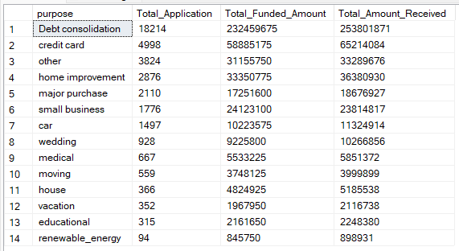

- Loan Amount Status by Home Ownership
SELECT
home_ownership,
COUNT(id) as Total_Application,
SUM(loan_amount) as Total_Funded_Amount,
SUM(total_payment) as Total_Amount_Received
FROM bank_loan_data
GROUP BY home_ownership
ORDER BY COUNT(id) Desc;
